 | Online Blood Bank Management System  Technical Design Document  2.0
 | Prepared By / Last Updated By | Reviewed By | Approved By
Name | Soundarya Lakshmi S , Manipriya T ,Manikandan J, Lakshmi S R, Aaysha Begam A . | Soundarya Lakshmi S , Manipriya T ,Manikandan J, Lakshmi S R, Aaysha Begam A . | Poonkuzhali Anand .
Role | Team Member | Team Member | Scrum Master
Signature
Date

Table of Contents

1.0 Introduction 3
1.1 Purpose of this document 3
1.2 Scope 3
1.3 Intended Audience 3
1.4 Definition & Acronyms 3
2.0 Conventions and Standards Followed 4
3.0 Assumptions, Dependencies and Risks 4
3.1 Assumptions: 4
3.2 Dependencies: 4
4.0 Schematic Diagram 4
5.0 Use Case Realization 5
5.1.1 User Registration 5
a. Functional Requirement 6
b. UI Validations 6
c. UI Controls 7
d. UI Methods Definition 8
e. UI Design 9
6.0 Database Design 10
6.1 Data Model 10
6.2 Tables Structure 10
7.0 Change Log 13

Introduction

Purpose of this document
The purpose of the detail design document is to define the detailed design for all the components of Online Blood Bank Management system that are specified in the Business Requirement/Use case document. All the low level components, interfaces and integrations are detailed out in this document.

Scope
This sub-section shall state the scope of this detailed design document
• Create and maintain Donor information.
• Create and maintain R information

Intended Audience
The intended audience for this document are
- Developers, testers, other associates in the project
- Technical lead, Scrum Master
- Product Owner

Definition & Acronyms
Acronyms | Definitions
OBBMS | Online Blood Bank Management System

Conventions and Standards Followed
The modules under scope needs to adhere to the coding standards and guidelines
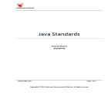
(Click the above icon for java standards and guidelines)

Assumptions, Dependencies and Risks

Assumptions:
- Once the application is built the Online Blood Bank Management System will manually load the user list into the system.
- There will be no concurrent users for the application. The Recipient profile will be maintained by the User.
- Any changes to the design mentioned in the BRD would be taken as a Change Request.

Dependencies:
- Availability of database design characteristics & access shall be defined by the
Resource availability throughout each of the sprint

Schematic Diagram
A schematic, or schematic diagram, is a representation of the elements of a system using abstract, graphic symbols rather than realistic pictures. It gives an overview of overall system

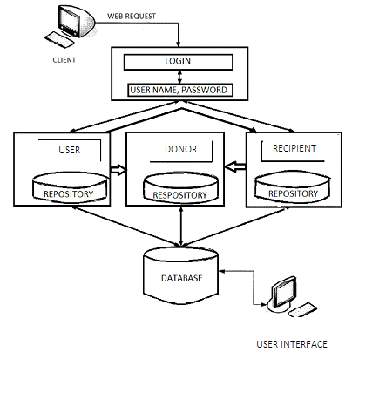
The above pic is only an example and not representational of the Online Blood Bank Management System.

Use Case Realization

User Registration

5.1.1.1 User Registration

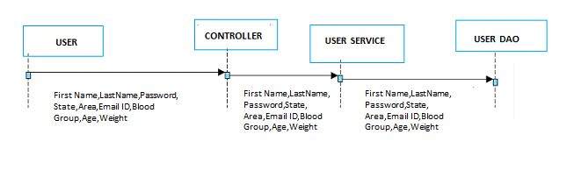

5.1.1.2 Login Page

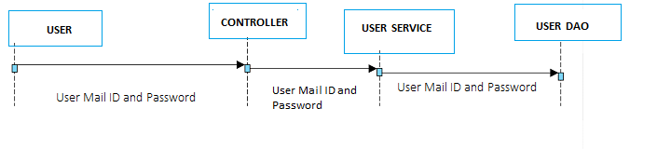

5.1.1.3 Registration Flow

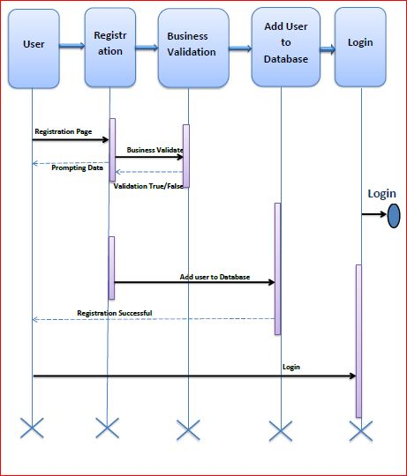

Functional Requirement
. Login Page checks the authentication of the user and directs the user to the respective page. User who wants blood can search the donor by using suited blood group as well as area. If the donor is found, User can contact donor. If the user did not find the matching donor, User can post the requirement in the home page so that anyone who is visiting the page can be able to view the list of recipients who needs blood. Recipients who are in need of blood are listed in the table which contains the following fields: Name, Blood Group, Location and Hospital. The donors who meet the recipient’s requirement can donate the blood.

UI Validations
- User Mail ID and Password fields are mandatory.
- Invalid User Id and / or password should not allow the user to get into the system

UI Controls
# | UI Component | Type | Name | Details
1 | User Mail ID | Label | label_For_User_Mail_ID
2 | user | Text field | Textfield_user | To enter username
3 | password | Label | Label_for_password
4 | password | Text field | Textfield_password | To enter password
-

UI Methods Definition
Method Name | Parameter | Details
SignButton_Click | object sender, EventArgs e | Allows the user to login into the portal and register the patient.
ResetButton_Click | object sender, EventArgs e | Clears the details entered by the user.
HomeButton_Click | object sender, EventArgs e | Loads the Homepage after registration is done successfully.

RegisterButton_Click | object sender, EventArgs e | Allows the user to insert the User personal details
ResetButton_Click | object sender, EventArgs e | Resets all fields given by user.
SearchDonor_Button_Click | object sender, EventArgs e | Allows the user to search the donor by using suited blood group as well as area. If the donor is found, User can contact donor.
Inbox_Button_Click | object sender, EventArgs e | Allows the user to view the details of the donor and the slot booked details for the recipient who is posted by that user. The details will get displayed till the booked date.
PostRequirement_Button_Click | object sender, EventArgs e | Allows the user to post the requirement in the home page so that anyone who is visiting the page can be able to view the list of recipients who needs blood.
BloodRequirement_Button_Click | object sender, EventArgs e | Allows the user to view the recipient’s details.
BookingSlot_Button_Click | object sender, EventArgs e | Allows the user to book a slot for blood donation. The date to be chosen must be on or before the recipient’s due date.
Feedback_Button_Click | object sender, EventArgs e | Allows the user to share feedback of blood donation.
Logout_Button_Click | object sender, EventArgs e | Allows the user to logout his/her account.

UI Design
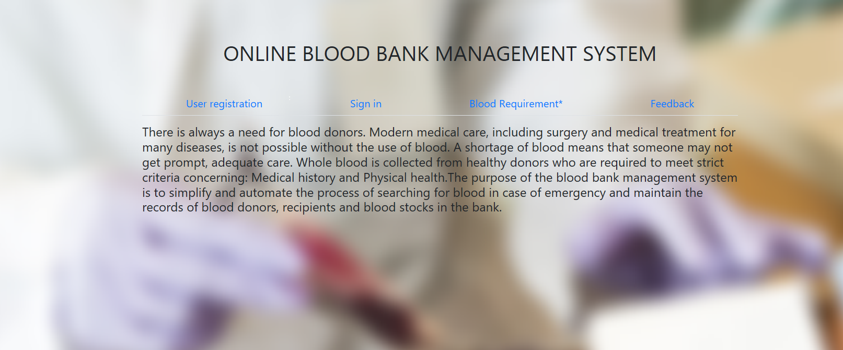

Database Design

Data Model

The following is a schematic view of the database design
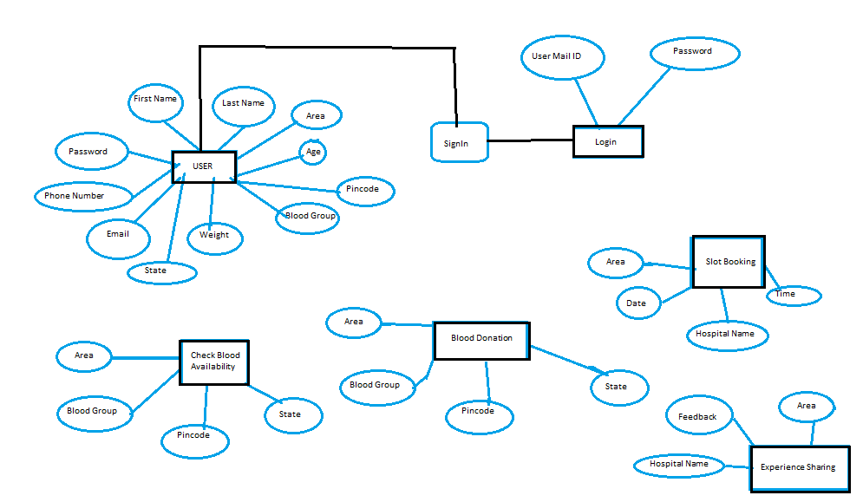

Tables Structure

User Registration:
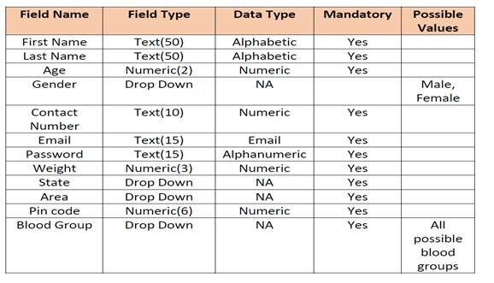

Post Requirement:
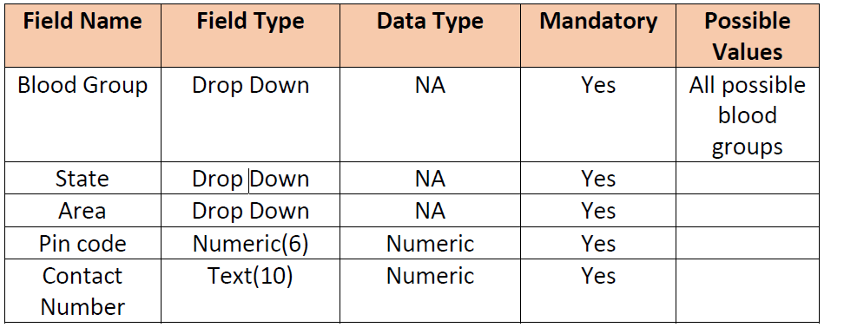

Blood Donation:

Slot Booking:

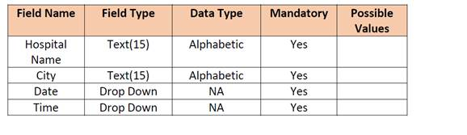

Feedback Comments:

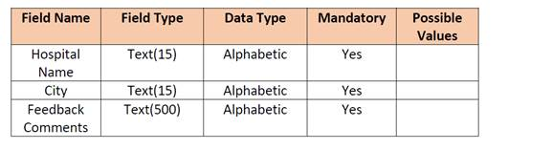

Change Log
Please note that this table needs to be maintained even if a Configuration Management tool is used.
Version Number | Changes made
V1.0 | <First version>
V 2.0 | <If the change details are not explicitly documented in the table below, reference should be provided here>
V 2.0 | Page no | Changed by | Effective date | Changes effected
V 2.0 | 13 | Aaysha Begam A, Lakshmi SR, Manikandan J, Manipriya T, Soundarya Lakshmi S. | 18/06/2019 | User Inbox has been created. The slot booking is done based on the recipient due date. If the donor choose the date after the due date, it will alert the donor to choose the date on or before the due date. The recipient and the donor details are displayed based on the blood compatibility types.
V1.2 | <If the change details are not explicitly documented in the table below, reference should be provided here>
V1.2 | Page no | Changed by | Effective date | Changes effected

